Manual Testing Master Class
Part 1

Rules:
- Focus on ONE thing at a time
- Use Tracker to update daily
- Update GitHub / Excel sheet
- 95% Try & Fail Try Again Success
- 5% Planning
- 50% is Perfect, 100% is Failure
- 40-70% Start giving interview
- Rejection is Part of Life

What is Software?
Set of instructions or commands that tells a computer what to do.

Types of Software

- System Software
Ex. Device Drivers, OS, Servers, Utilities etc

- Programming Software
Ex. Compilers, debuggers, interpreters, etc

- Application Software
Ex. Web Applications, Mobile Apps, Desktop App etc.

System software | Application Software
Basically, Controls a computer’s internal functioning | Designed to perform a specific task for end-users  Product or program that is designed only to fulfilled end-users requirement
OS  Language Processor  Device Driver | Ms-Word, Excel, pp etc

What is Software Testing?
Process of evaluating and verifying that software product or application does what it is supposed to do.

Expect Result (requirement) = Actual Result (By doing QA)
Verify Expected result from requirements to the actual result by doing it for QA

- Software Testing is a part of Software Development Process
- Main Objective of Testing is to release quality product to the client
- Activity to identify the defects in the software (Not Fix)

What is Software Testing Objective?
- Evaluate work product
- Verify requirement
- Validate test objects
- Build confidence
- Reduce Risk
- Share information to Stakeholders
- Find failure & defects
- Prevent defects

finding defects
Gaining confidence in and providing information about the level of quality
end result meets the business and user requirements
Quality Product

If you get 10 bugs but asked for only P01 bug then will you report all 10 bugs or only P01 bug?
Requirements we need to check required bugs only should be submitted
other bugs should be Discussed with BA, Dev

Discussions are very important hence there are multiple meetings

What are the Requirements?
Doc. That contains what to build, how this is useful for the client
BA gather all this information
not necessary to have BA in every project
Product Managers / Owner collect this info, if no BA
Some times there will be no requirement given, directly web application is given

What is Quality?
Defined as justification of all the requirements of a customer in a product

Quality software is Means
- Bug-free
- Delivered on time
- Within budget
- Meets requirements and/or expectations
- Maintainable

To check whether the Actual software product matches Expected requirements and to ensure that software product is Defect free.

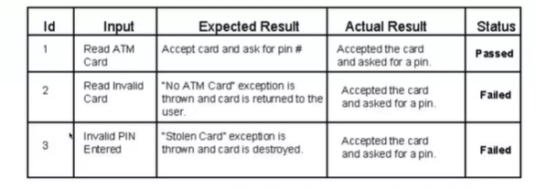
Testcases given for ATM application

Is AI going to replace Testing jobs?
No, bcz AI cannot create repeated 100s of testcases with different email ids
Special Characters are added in email id which is not right
Big LLMs / AI software’s are coming, needs Testers

How AI is helping?
before I use to write 10 Testcase now AI is suggesting me some new testcases and I am able to write 12 Testcase at a time

Benefits of Software Testing
- Cost-Effective
- Product quality
- Customer Satisfaction

